Memes for No Assisted Suicide
(for bulletins, (e)newsletters, websites, social media, etc)

Memes are shareable courtesy of the USCCB Pro-Life Office and are from the 2015-16 Respect Life Program. Accompanying text has been adapted for our use. Spanish versions and more memes can be found at http://www.usccb.org/about/pro-life-activities/respect-life-program/2015/shareable-respect-life-graphics-respect-life-program-2015-16.cfm

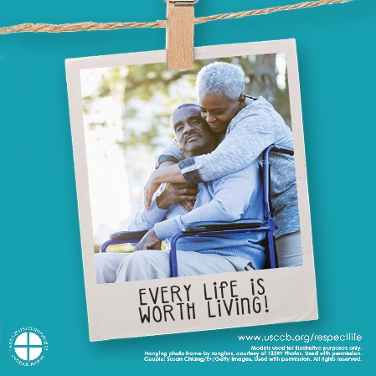
At every stage & in every circumstance, we are held in existence by God's love. nyscatholic.org/stop-assisted-suicide/ #noassistedsuicideny #RespectLife

(133 characters)

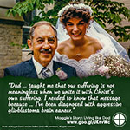
Although Maggie passed away late in 2015, her courage continues giving hope: goo.gl/JKnvWc. nyscatholic.org/stop-assisted-suicide/ #noassistedsuicideny

(137 characters)

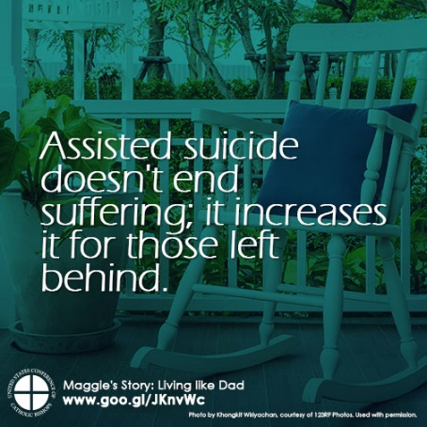
Maggie's Story goo.gl/JKnvWc: "Assisted suicide...involves more than just the patient." nyscatholic.org/stop-assisted-suicide/ #noassistedsuicideny

(136 characters)

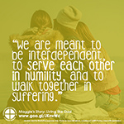
In her final days, Maggie shared a legacy that can transform the world. goo.gl/JKnvWc nyscatholic.org/stop-assisted-suicide/ #noassistedsuicideny

(130 characters)

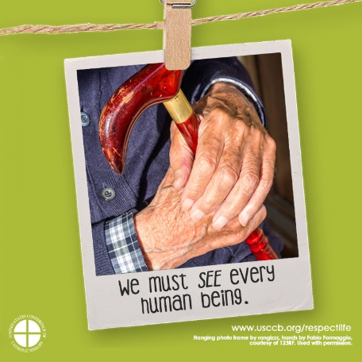
The human person is always precious, even if marked by illness or old age. Pope Francis nyscatholic.org/stop-assisted-suicide/ #noassistedsuicideny

(130 characters)

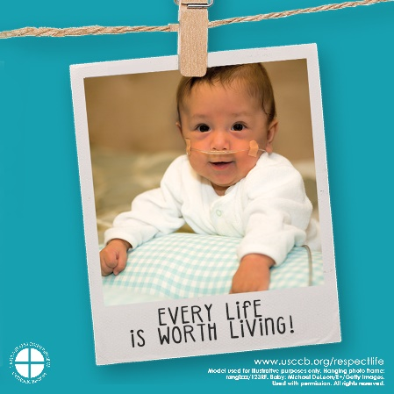
Our ability or prognosis doesn’t define our worth. We are loved and made in the image of God. nyscatholic.org/stop-assisted-suicide/ #noassistedsuicideny

(134 characters)

