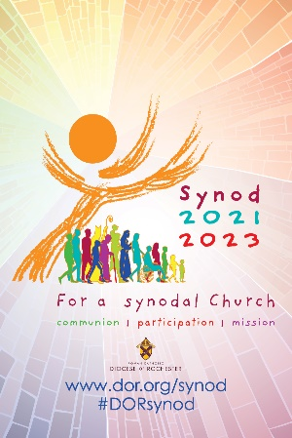
Scripture Verse References for Synodal Themes:

Fundamental question regarding “journeying together”:
- The 3 actors on the journey: Jesus “the protagonist”, the crowd, and the apostles (references taken from the Vatican Preparatory Document):
  - Jesus: PD # III.17
  - The Crowd: PD # III. 18
  - The Apostles: PD # III. 19
- The Holy Spirit who guides us:
  - Jn 16: 12-15

Themes:
- The Journeying Companions (Accompaniment)
  - Lk 24: 13-35 (Road to Emmaus)
  - 1 Cor 13: 1-13 (Love is patient…)
- Listening (Who listens and who do we listen to)
  - Lk 4: 16-21 (The Spirit of the Lord is upon me…)
- Speaking Out (… with authenticity, courage and candidly)
  - Mk 12: 38-44 (The generous widow)
  - Mk 10: 46-52 (Bartimaeus)
  - 2 Tim 2: 8-13 (Paul offers up his sufferings for the salvation of others)
- Celebrating (Celebration occurs through prayer and the Eucharist)
  - Jn 15: 7-14 (I am the vine; you are the branches…)
  - Lk 6: 17, 20-26 (The Beatitudes)
- Co-Responsible in the Mission (We are all in this together)
  - Lk 3: 10-18 (What can I do?)
  - Acts 2: 1-11 (Pentecost)
- Dialogue in Church and Society (We are all the People of God)
  - Eph 3: 2-3a, 5-6 (We are co-heirs of the Kingdom)
  - 1 Cor 12: 12-14, 18-27 (Members of the same body)
- With the Other Christian Denominations (Our Christian brothers & sisters)
  - Lk 3: 15-16, 21-22 (John said: “I baptize you with water…”)
- Authority and Participation (Working towards the same mission with respect)
  - Lk 4: 21-30 (No prophet is welcome in their own home)
- Discerning and Deciding (… together and guided by the Holy Spirit)
  - Jn 14: 15-17 (If you love me, you’ll keep my commandments…)
- Forming Ourselves in Synodality (Learning to live this way of BEING Church
  - Jn 17: 11-21 (Jesus’ prayer)
  - Lc 6: 39-45 (Can a blind person lead another blind person…)

